SOIL CLASSIFICATION
The principal objective of soil classification is the prediction of engineering properties and behavior of a soil based on a few simple laboratory or field tests. The results of these tests are then used to identify the soil and put it into a group of soils that have similar engineering characteristics. Although there are several different methods of soil classification, the method adopted for use by the military is the Unified Soil Classification System (USCS)
Soils seldom exist in nature separately as sand, gravel, or any other single component. Soils usually form mixtures with varying proportions of different size particles. Each component contributes to the characteristics of the mixture. The USCS is based on the textural or plasticity-compressibility characteristics that indicate how a soil will behave as a construction material.
In the USCS, all soils are divided into three major divisions: (1) coarse grained, (2) fine grained, and (3) highly organic. As you know from your previous studies, coarse-grained and fine-grained soils are distinguished by the amount of material that is either retained on or that passes a No. 200 sieve. If 50 percent or more of the soil by weight is retained on a No. 200 sieve, then the soil is coarse-grained. It is fine-grained if more than 50 percent passes the No. 200 sieve. Highly organic soils can generally be identified by visual examination. The major divisions are further subdivided into soil groups. The USCS uses 15 groups and each group is distinguished by a descriptive name and letter symbol, as shown in table AV-1 of appendix V. The letter symbols are derived either from the terms descriptive of the soil fractions, the relative value of the liquid limit (high or low), or the relative gradation of the soil (well graded or poorly graded). The letters that are used in combination to form the 15 soil groups areas follows

COARSE-GRAINED SOILS
Coarse-grained soils are divided into two major divisions: gravels and sands. If more than half of the coarse fraction by weight is retained on a No. 4 sieve, the soil is a gravel. It is classed as a sand if more than half of the coarse fraction is smaller than a No. 4 sieve. In general practice there is no clear-cut boundary between gravelly and sandy soils, and as far as behavior is concerned, the exact point of division is relatively unimportant. Where a mixture occurs, the primary name is the predominant fraction and the minor fraction is used as an adjective. For example, a sandy gravel is a mixture containing more gravel than sand by weight.
For the purpose of systematizing the discussion, it is desirable to further divide coarse-grained soils into three groups on the basis of the amount of fines (materials passing a No. 200 sieve) they contain. GW, GP, SW, and SP Groups
Coarse-grained soils with less than 5-percent nonplastic fines may fall into the groups GW, GP, SW, or SP. The shape of the grain size distribution curve determines the second letter of the symbol.
GW AND SW GROUPS.— The GW groups contain well-graded gravels and gravel-sand mixtures that contain little or no nonplastic fines. The presence of the fines must not noticeably change the strength characteristics of the coarse-grained fraction or interfere with its free-draining characteristics. The SW groups contain well-graded sands and gravelly sands with little or no plastic fines.
GP AND SP GROUPS.— The GP group includes poorly graded gravels and gravel-sand mixtures containing little or no nonplastic fines. The SP group contains poorly graded sands and gravelly sands with little or no nonplastic fines. These soils will not meet the gradation requirements established for the GW and SW groups.
GM, GC, SM, and SC Groups Coarse-grained soils containing more than 12-percent fines may fall into the groups designated GM, GC, SM, and SC. The use of the symbols M and C is based upon the plasticity characteristics of the material passing the No. 40 sieve. The liquid limit andplasticity index are used in specifying the laboratory criteria for these groups. Reference also is made to the plasticity chart shown in figure 16-3 that is based upon established relationships between the liquid limit and plasticity index for many different fine-grained soils. The symbol M is used to indicate that the material passing the No. 40 sieve is silty in character. An M usually designates a fine-grained soil of little or no plasticity. The symbol C is used to indicate that the binder soil is predominately clayey in character.
GM AND SM GROUPS.— Typical of the soils included in the GM group are silty gravels and gravel-sand-silt mixtures. Similarly, the SM group contains silty sands and sand-silt mixtures. For both of these groups, the Atterberg limits must plot below the A-line of the plasticity chart (fig. 16-3). The plasticity index must be less than 4.
GC AND SC GROUPS.— The GC group includes clayey gravels and gravel-sand-clay mixtures. Similarly, SC includes clayey sands and sand-clay mixtures. For both of these groups, the Atterberg limits must plot above the A-line with a plasticity index for more than 7.
Borderline Soils Coarse-grained soils that contain between 5 and 12 percent of material passing the No. 200 sieve are classed as border line and are given a dual symbol, such as GW-GM. Similarly, coarse-grained soils that contain more than 12 percent of material passing the No. 200 sieve, and for which the limits plot in the shaded portion of the plasticity chart (fig. 16-3), are classed as border line and require dual symbols, such as SM-SC. It is possible in rare instances for a soil to fall into more than one borderline zone. In this case, if appropriate symbols were used for each possible classification, the result would be a multiple designation consisting of three or more symbols. This approach is unnecessarily complicated. It is considered best to use only a double symbol in these cases. You should select the two that you believe to be most representative of the probable behavior of the soil. In cases of doubt, the symbols representing the poorer of the possible groupings should be used. For example, a well-graded sandy soil with 8 percent passing the No. 200 sieve, an LL of 28 and a PI of 9 would be designated as SW-SC. If the Atterberg limits of this soil are such as to plot in the shaded portion of the plasticity chart (for example, LL 20 and PI 5), the soil is designated either SW-SC or SW-SM; it depends on the judgment of the engineer from the standpoint of the climatic region in which the soil is located.
FINE-GRAINED SOILS
The fine-grained soils are not classified on the basis of grain size distribution, but according to plasticity and compressibility. Laboratory classification criteria are based on the relationship between the liquid limit and plasticity index as designated in the plasticity chart in figure 16-3. This chart was established by the deter- mination of limits for many soils, together with an analysis of the effect of limits upon physical characteristics. Examination of the chart shows that there are two major groupings of fine-grained soils. Thase are the L groups, which have liquid limits less than 50, and the H groups, which have liquid limits equal to and greater than 50. The symbols L and H have general meanings of low and high compressibility, respectively. Fine-grained soils are further divided with relation to their position above or below the A-line of the plasticity chart.
ML and MH Groups Typical soils of the ML and MH groups are inorganic silts. Those of low compressibility are in the ML group. Others are in the MH group. All of these soils plot below the A-line of the plasticity chart. The ML group includes very fine sands, rock flours (rock dust), and silty or clayey fine sand or clayey silts with low plasticity. Loess type soils usually fall into this group. Diatomaceous and micaceous soils usually fall into the MH group but may fall into the ML group when the liquid limit is less than 50. Plastic silts fall into the MH group
CL and CH Groups In these groups, the symbol C stands for clay, with L and H denoting low or high liquid limits. These soils plot above the A-line and are principally inorganic clays. In the CL group are included gravelly clays, sandy clays, silty clays, and lean clays. In the CH group are inorganic clays of high plasticity.
OL and OH Groups The soils in these two groups are characterized by the presence of organic matter; hence the symbol O. All of these soils generally plot below the A-line. Organic silts and organic silt-clays of high plasticity fall into the OL group, while organic clays of high plasticity plot in the OH zone of the plasticity chart. Many of the organic silts, silt-clays, and clays deposited by the rivers along the lower reaches of the Atlantic seaboard have liquid limits above 40 and plot below the A-line. Peaty soils may have liquid limits of several hundred percent and plot well below the A-line because of their high percentage of decomposed vegetational matter. A liquid limit test, however, is not a true indicator in cases in which a considerable portion consists of other than soil matter.
Borderline Soils Fine-grained soils that have limits that plot in the shaded portion of the plasticity chart are borderline cases and are given dual symbols, such as CL-ML. Several soil types that exhibit low plasticity plot in this general region on the chart where no definite boundary between silty and clayey soils exists.
HIGHLY ORGANIC SOILS A special classification (Pt) is reserved for the highly organic soils, such as peat, which have characteristics that are undesirable for construction materials and foundations. No laboratory criteria are established for these soils, as they generally can be readily identified in the field by their distinctive color and odor, spongy feel, and fiequently, fibrous textures. Particles of leaves, grass, branches, or other fibrous vegetable matter are common components of these soils.
COEFFICIENT OF UNIFORMITY

In table AV-1 of appendix V, you can see that well-graded gravels (GW) and well-graded sands (SW) must meet certain requirements with regard to C_{u} and C_{c}, C_{u} means the coefficient of uniformity with regard to the plotted grain size curve for the material. To see how the coefficient of uniformity is determined, let’s consider an example.
Sieve | % passing
3/8 | 100
No 4 | 85.8
10 | 74.4
20 | 51.2
40 | 30.2
100 | 16.3
200 | 3.3
Suppose that the sieve analysis of a soil sample identified as FT-P1-1 is as shown in the opposite Table.

You should plot these values on a form like the one shown in figure 16-4. The graph on this form is a logarithm type of layout; coordinates horizontally are sieve sizes (at the top) and grain sizes in millimeters (at the bottom). Vertical coordinates are percents passing.
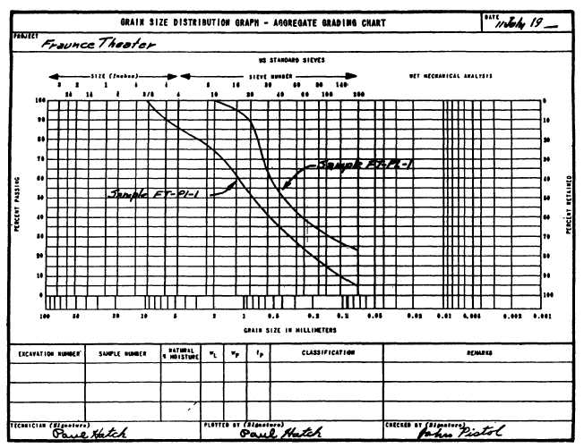
Figure 16-4.—Grain size distribution chart.

The formula for determining Cu is as follow: 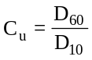
D means the grain size, in millimeters, indicated by the gradation curve at the 60-percent passing level. In figure 16-4, follow the 60-percent passing line to the point where it intersects the gradation curve for FT-P1-1; then drop down and read the grain size in millimeters indicated below. You read about 1.25mm. D₁₀ means, similarly, the grain size indicated by the gradation curve at the 10-percent passing level. In figure 16-4, this is about 0.11mm.
C_{u} for this sample, then, is 1.25/0.11, or about 11.4.
COEFFICIENT OF CURVATURE
C_{c} means the coefficient of curvature of the gradation curve. Sometimes the symbol C_{g} for coefficient of gradation) is used instead of C_{c}. The formular for determine C_{c} or C_{g} is as follows:
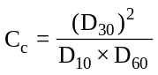
D₃₀ is the grain size, in millimeters, indicated by the gradation curve at the 30-percent passing level. In figure 16-4, it is (for FT-P1-1) about 0.35. Therefore, 0.35 therefore C_{c} is 0.35 divided by (0.11 x 1.25), or about 0.89.

FT-P1-1 is obviously a sand, since more than half of its coarse fraction passes the No. 4 sieve. It is a clean sand, since less than 5 percent of it (see table AV-1, appendix V) passes the No. 200 sieve. However, it is not a well-graded sand (SW), because although its C_{u} is greater than 6 (prescribed for SW in appendix V), its C_{c} is less than 1, the minimum prescribed for SW.

